**2025-2026**

**STUDENT DRESS CODE for ALL K-8 STUDENTS**

*All students should be in uniform on the first day of school.*

*All final uniform violations decisions are at the discretion of the principal or designee.*

**ALL STUDENTS**

Shirts

* Solid colored polo shirts in **white, hunter green, or navy blue** are permitted to be polyester/cotton blends or knit material.
* *Shirts are not to have any emblem except St. Mary's on it*.

Dress Shorts

* Girls and boys may wear navy or khaki, plain front, uniform shorts (in the style of walking dress shorts) from August through October and from April 1 until the close of school. No other shorts are acceptable.

Shoes (refer to pictures for allowable styles)

* Shoes must be understated (solid or with minimal neutral accents) and have no print
* Sandals, slippers, flip-flops, Crocs, moccasins, backless shoes are not permitted.
* Winter boots must be a solid color but should be changed upon arrival to school. Above the knee boots may not be worn.
* Shoe heels and soles should be no greater than 1”.
* **When in question, ask the principal before purchasing!**

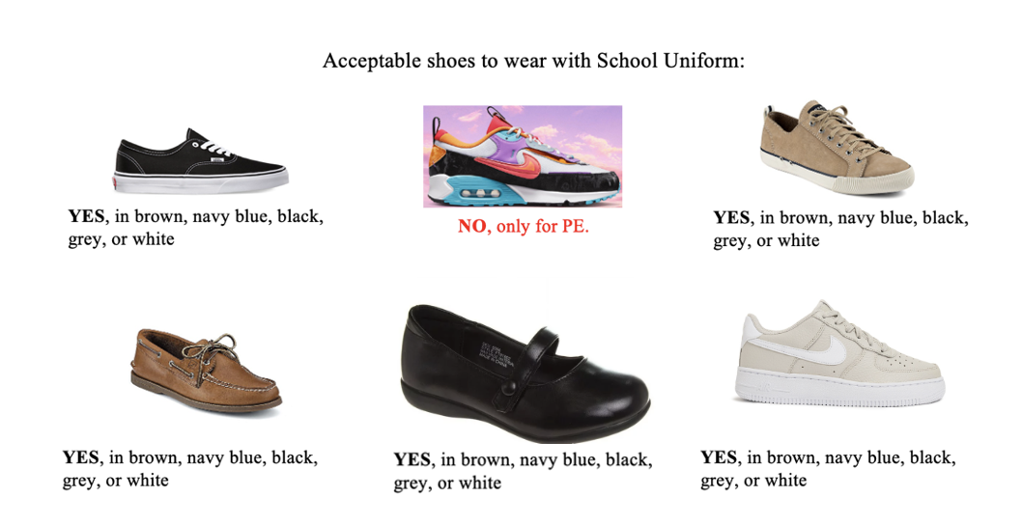

**Sweaters/Sweatshirts**

* Solid, plain cardigan or pullover sweaters in the following colors: **hunter green, navy blue, white, grey, and black**
* Only St. Mary's School, SMB, Western, or Crusader official sports team, or CCHS sweatshirts may be worn.

**Hair**

* Hair is to be clean, neat and well combed. No vibrant colors/colors that cannot be grown naturally are permitted.

**PE Clothes**

* All required PE clothes can be ordered from the school.
* T-shirts are royal blue and have the St. Mary's logo on the front. They must be purchased from the school office
* PE shorts are grey mesh basketball shorts and cannot be shorter than 3in above the knee for males and females.
* PE pants are grey sweatshirt material and can be worn when the weather is cold. Logos on pants should be no bigger than quarter size. Leggings are not permitted.

**Out of Uniform Days**

On special occasions, students are granted an out-of-uniform day.

* Jeans or sweatpants can be worn on out of uniform days. *Jeans should be in good repair (i.e., no holes, fraying, etc.) fitted at the waist and off the floor*.
* No leggings. No form-fitting/skin tight bottoms are permitted.
* No pajama tops or bottoms are permitted with the exception of specified PJ day.
* No inappropriate messages, political statements, or graphics are permitted on shirts.
* Shoes should always be worn according to the dress code.
* No midriff or undergarments should be visible, shoulders should be covered
* No excessive jewelry is permitted.

**MASS DAYS**

* Girls should wear their plaid uniform skirts or jumpers with a white shirt, or uniform pants/shorts (during allotted time only) with a ***white button down dress blouse.***
* Shirts are to be tucked in.
* Boys must wear a ***white dress shirt*** with the school plaid tie or solid navy-blue tie.
* Shirts should be tucked in and pants with belt loops worn with a belt.
* Boys must wear navy or khaki uniform pants/shorts (during allotted time only).

**BOYS GRADES K-8**

**Pants**

* Navy blue or khaki dress pants in twill type material or dress corduroy.
* No jeans. Cargo pants, sweatpants, etc. are permitted.

**Shirts**

* *Shirts are not to have any emblem larger than the size of a quarter with the exception of the St. Mary's Logo on it*.
* In colder weather, boys may wear white, hunter green, or navy turtleneck shirts or plain white short-sleeve T-shirts under the school shirt.
* SHIRTS MUST BE TUCKED IN.

**Jewelry**

* ONE Traditional watch (no smart watches) is permitted
* ONE necklace of religious orientation (cross or medal) is permitted.
* No more than TWO bracelets are permitted
* No facial, ear, or body piercings.

**Socks**

* Must be solid navy, black, brown, white, or grey.

**Hair**

* Boys' haircuts should be cut above the ears and the eyebrows and cut above the collar and should have no definite lines in the cut, no tails, ponytails, or buns.
* No long sideburns or facial hair is permitted.
* The decision of the principal is final.

**GIRLS GRADES K-8**

**Jumpers/skirts**

* School Plaid Jumpers are worn in grades K-4. However, girls in grade 4 can wear the school plaid skirt or the school plaid jumper.
* Grades 5-8 wear the school plaid skirt.
* Jumpers and skirts may be***no more than three inches above the knee***. Girls may not "roll" uniforms to make them shorter.
* Girls must wear shorts (bike or cartwheel length) or leggings/tights under their skirts.

S**hirts**

* *Shirts are not to have any emblem larger than the size of a quarter with the exception of the St. Mary's Logo on it*.
* Blouses or knit polo shirts with collars are to be plain white, hunter green, or navy blue. Collars may be pointed, Peter-Pan, or button-down in style. Blouses should not have any lace or designs.
* Blouses/shirts are to be tucked in. Blouses may not be tightly fitted or too short to stay tucked in.
* White, hunter green, or navy turtlenecks are permitted in colder weather.

**Pants**

* Navy blue or khaki dress pants.
* No jeans, cargo pants, jeggings, leggings, sweatpants, etc. are permitted.

**Jewelry**

* A traditional watch (no smart watches) is permitted
* No more than TWO bracelets are permitted
* No more than TWO modest (close to the earlobe)-earrings per earlobe are permitted.
* ONE necklace of religious orientation (cross or medal) is permitted.
* No facial or body piercings.

**Socks**

* Knee socks or crew socks in solid navy, hunter green, or white color.
* Tights or Leggingsin solid navy, hunter green, grey, black, or white colors are permitted to be worn under the skirt.

**School approved plaids** *(Hunting Tartan)* **can be purchased at:**

- Lands End

- School Belles

- French Toast

- Uniform Guy

**Hair**

* Hair is to be clean, neat and well combed. No vibrant color/colors that cannot be grown naturally is allowed.

**Accessories/Make-up**

* Modest hair bands, ribbons, and headbands are permitted.
* Middle School Girls are permitted to wear natural-looking cosmetics
* Nails may be painted clear, pale pink, or French tip. No artificial/acrylic nails are permitted