SMS COACHING REQUIREMENTS

Paperwork (All paperwork hyperlinked at https://www.starkcountycatholicschools.org/Forms_SMA.aspx)

Emergency Medical Authorization – Parent completes for each sport. Coach keeps at all times. Send with paramedics in the event of an emergency. https://www.starkcountycatholicschools.org/Downloads/Emergency%20Medical%20Authorization%20Form%202019.pdf

Code of Conduct – Completed by parent & student for each sport. Coach keeps at all times. St. Michael's Athletic Handbook

OHSAA Physical Form – Physician completed (Grades 7 & 8). Turned into office for filing. Valid for 12 months. Students in grade 1-6 only need participation form/prescription signed by physician.
Ohio High School Athletic Association

Lindsay’s Law (Sudden Cardiac Arrest Training) – Acknowledgement form to be completed by coaches and parents. Form turned into office for filing. Parents form at. . . Parent/Athlete Signature Form
Coaches form at. . .
Information for the Coach

Concussion Information Sheet
Ohio Department of Health Concussion Information Sheet

Attend a “Diocese of Youngstown Treasured Gift of God” class. Search “Youngstown Diocese” at VIRTUS® Online for schedule. Instructions for setting up a VIRTUS account can be found here:
Please note: In light of the current health concerns, one prudent and preventative measure we can take is to make the VIRTUS Protecting God's Children training available Online as an option. This change is temporary and will be re-evaluated as public health recommendations continue to evolve.

Head coaches of all grades and assistant coaches grades 7-8 complete an FBI/BCI Background Check.
Q: Where do I go to get my BCI/FBI check?

A: Typically, any BMV offers this service. You may want to call ahead to confirm their hours and method of payment before going.

Q: The bureau is asking for a code? What is the code?

A: The code is 2151.86

Q: Where do I send my background check?

A: All background checks have to be sent to the Catholic Diocese of Youngstown, Attn: Safe Environment Office, 144 West Wood Street, Youngstown, Ohio 44503

Q: How long does it take for the school to receive my background check?

A: Results can take up to three weeks. Please note that until we receive the results of the BCI/FBI you will not be permitted to volunteer, attend class parties, or coach.

https://www.starkcountycatholicschools.org/Downloads/Background%20Check%20Form%20(for%20Grades%207-8%20and%20Head%20Coaches%20for%20all%20Grades).jpg

Assistant coaches grades 1-6 complete BCI Background Check https://www.starkcountycatholicschools.org/Downloads/Background%20Check%20Form%20(for%20Grades%201-6%20Assistant%20Coaches).jpg

Injury Report Form – to be filled out within 24 hrs of injury. https://www.starkcountycatholicschools.org/Downloads/Injury%20Report.pdf or online at SMS Athletic Forms

Participation Fee Payments from Parents
- Pay online via WeShare at Home
- The Athletic Department will supply all essential game jerseys/uniforms. Non-essential apparel orders can be coordinated by a parent or a coach. Please communicate to all parents that these non-essential purchases are NOT mandatory.

Scheduling of Practices/Games
Schedules are created by league coordinators and through Bob Belden, Athletic Director, smscoaches@gmail.com.
- Schedules are maintained at https://www.starkcountycatholicschools.org/ESVTest.aspx
Please inform Bob Belden of any schedule changes.

Keep parents informed using Remind.com (described next page), TeamSnap, TeamReach, Shutterfly, or another form of group scheduling. Please invite Bob Belden to the Group you create.

Initial Team Contact
- Compose an introductory email. When ready to be sent, the Parish can retrieve entire classes’ email addresses, as necessary. Bob also has some examples of introductory emails from the past, if helpful.

Remind.com
- It is recommended that you create text/email groups using www.remind.com
- Sign up as a “teacher” for free (no special code required)
- Create a ‘class’ for each team or grade, etc. (ie. @smsSports)
- Ask parents/participants to sign up by texting your individually created “class code” to 810-10
- There is a downloadable PDF with sign up instructions for parents that can be printed and distributed to each participant with the class code included.

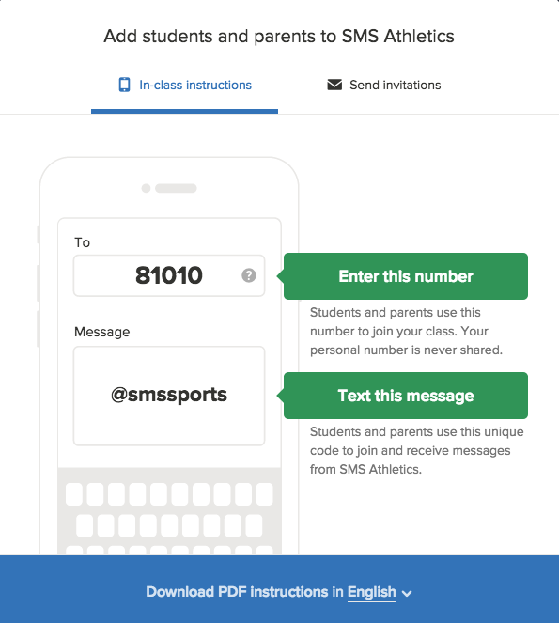

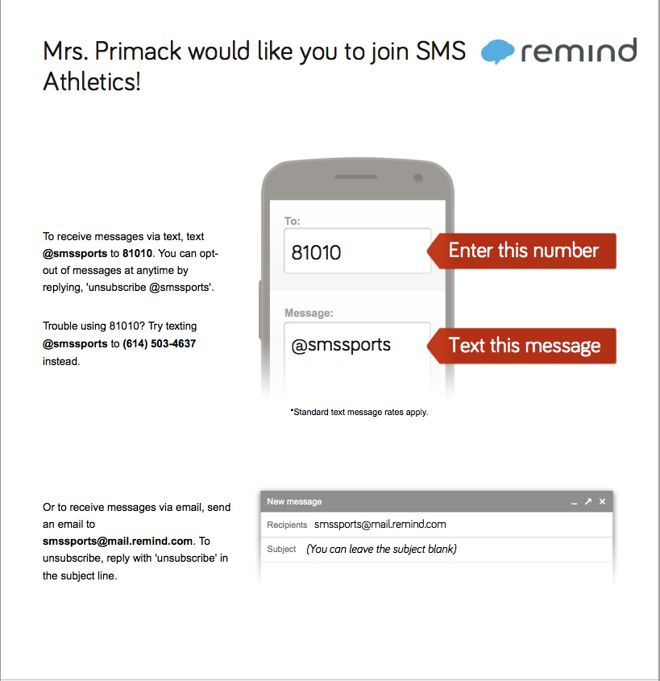

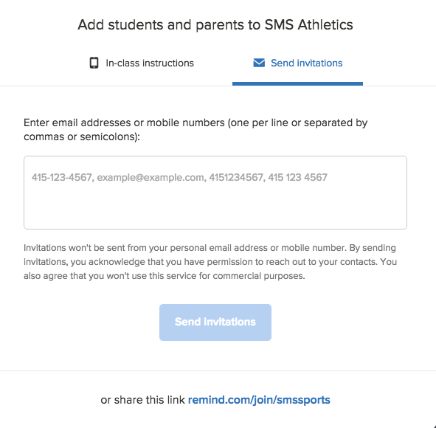
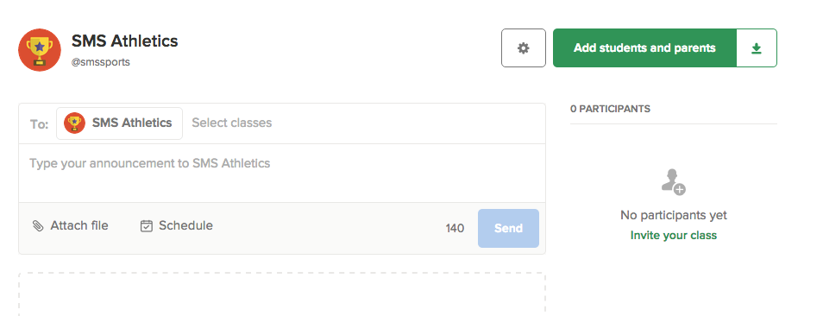
- Write your message using 140 characters or less and either schedule or send immediately for instantaneous correspondence (ie. Practice cancelled, change of game location or time, etc)
