St. James School
Giving children WINGS to fly!
400 W. Lisbon Street in Waynesburg, OH 44688
330-866-9556
Website: stjamesschoolwaynesburg.com
Email: stjameselem@youngstowndiocese.org

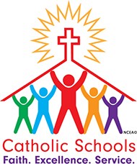
PARENT NEWS – FEBRUARY 2021
Principal’s Message,
During the week of February 21 – 26 St. James will celebrate Catholic Schools Week. The CSW theme is “Catholic Schools: Faith. Excellence. Service.” Catholic schools have a specific purpose to form students to be good citizens of the world, love God and neighbor and enrich society with the leaven of the gospel and by example of faith.
As communities of faith, Catholic schools instill in students their destiny to become saints. Academic excellence is the hallmark of Catholic education intentionally directed to the growth of the whole person – mind, body and spirit. Finally, service is fundamental to Catholic education and the core of Catholic discipleship. Service is intended to help form people who are not only witnesses to Catholic social teaching, but also active participants through social learning.
The CSW logo emphasizes that the Catholic school, like the Catholic Church, is not a building or an institution, but it is the people. As the people of God, we work together to bring the Kingdom of God to Earth and raise up the next generation to do the same. The image of teachers and students forming the foundation of the school shows that they are active people of faith who serve others and God. May we all strive to live in active service of Jesus and his mission as we nationally join together during Catholic Schools Week.

CSW is a time for celebration at St. James. We rejoice in our mission, plan fun activities, and show gratitude for those who make our school a great place to learn and grow. Included with this letter is the schedule for CSW activities. The schedule will be posted on our website as well.

During CSW we begin enrollment for next year. Be sure to read the testimonials from our parents and students included in this newsletter. And be sure to tell your friends and neighbors about our wonderful little school. May the Lord richly bless you, Kathy Kettler

Dates to Remember:
2/15 NO SCHOOL President’s Day
2/17 Ash Wednesday Mass 9am
Phys Ed classes

2/19 Stations of the Cross 9:45am
Fish Fry Drive-Thru 4-6pm

2/20 First Reconciliation Gr. 2 10am

2/21-26 Catholic Schools Week celebrations

2/26 CSW Mass 9am
Fish Fry Drive-Thru 4-6pm

SCHOOL NEWS
ACADEMIC ACHIEVEMENT
The following students have worked hard during the second quarter and have earned academic honors for their effort. Honor Roll consists of a 3.5-4.00 grade average. Merit Roll consists of a 3.0-3.49 grade average. We are proud of their performance and congratulate them on their success.
Honor Roll
Fourth Grade: Dakota Broad, Parker Capurso, Jon Casto, Carter Mockerman
Fifth/Sixth Grade: Bray Jones, Lauren Jones, Owen Mucci, Angelo Rossi
Merit Roll
Fourth Grade: Emilio Gonzales, Eli Higgs, Reagan Micco
Fifth/Sixth Grade: Doc Dexter, Leo Friedman, Lilly Rine, Logan Tullos
- Grades K-3 use a Standards based report card that lists a wide variety of skills in each subject area.

REMINDER
Doors open at 8:30am for students to arrive and staff to start taking temperatures.

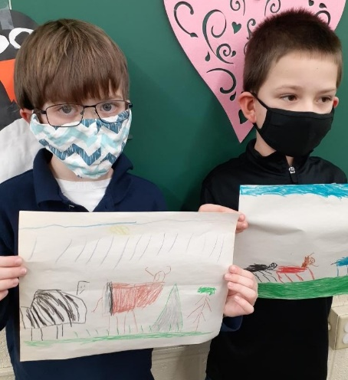
CLASSROOM LEARNING PROJECTS
First Grade Reading – The children made illustrations of animal teams. They read about animals that help each other out.

Pictured to the right are Evan & Lucas showing their Zebra and wildebeast drawings. Zebras and wildebeasts find food for each other and watch out for danger.
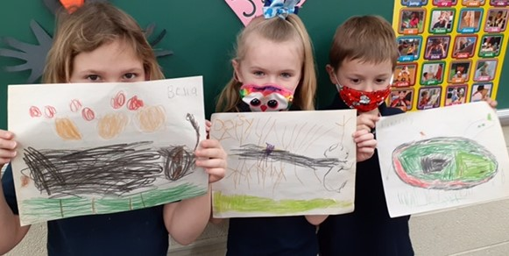
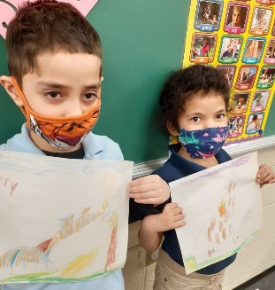

Jerry & Kendall display their giraffe art. Giraffes have little birds that eat the bugs off of them.
Above, Bella, Daisy and Timmy show their Rhinoceros drawings.
The Rhinoceros also has a bird that eats bugs on their skin.
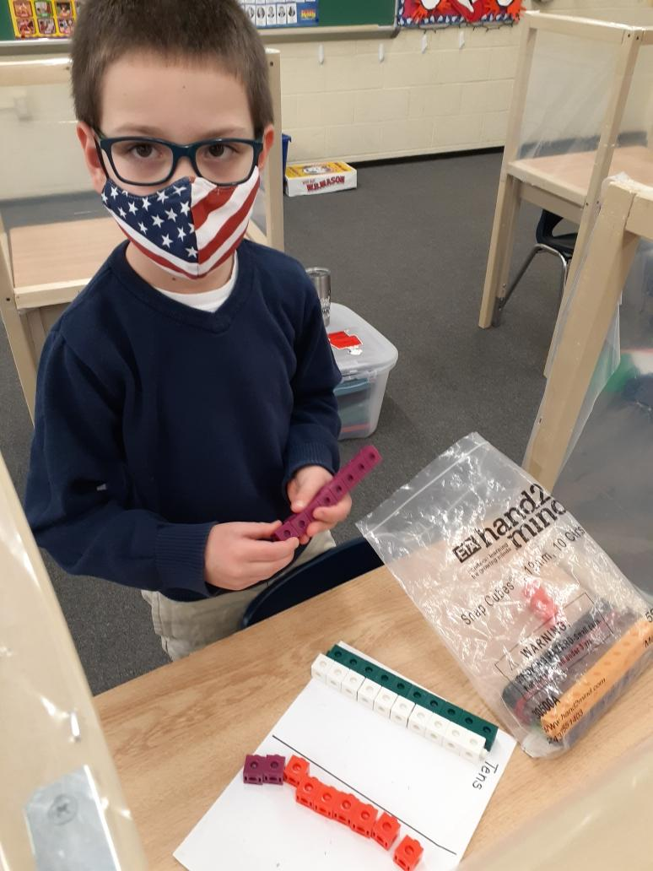
First Grade Math
Manipulatives help teach math concepts. Pictured is Lucas using cubes to learn to regroup in addition.

Second/Third Grade Art & Social Studies – The children learned about Chinese Lunar New Year. They watched videos about it and made their own Dragon Dance costumes.

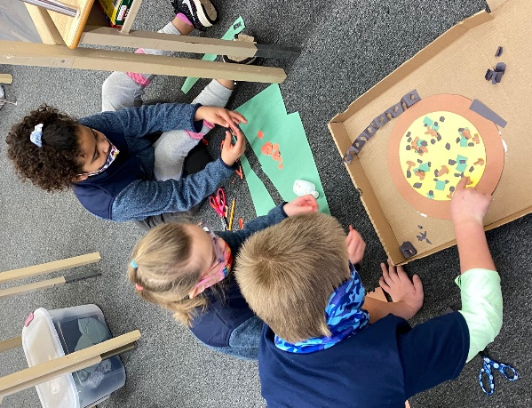
Third Grade Fraction Pizzas – The children made pizzas with six pieces. The whole pizza had 18 mushrooms, 24 pepperoni, 12 green peppers, and 30 black olives. The third graders calculated the number of each item per piece.

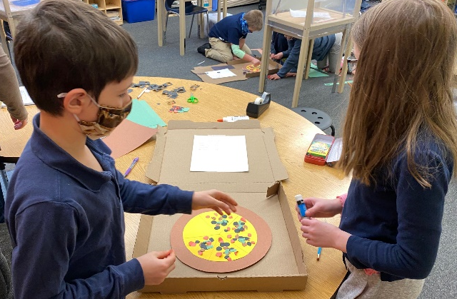
From left to right are James & Lilly; Hunter, Alice & Bree adding toppings to their pizza.

Fourth Grade Science STEM Project - The children are learning how to make complete circuits and parallel circuits using wire, a D-cell, and a flashlight bulb. They were given the materials with no explanation and had to figure it out on their own.

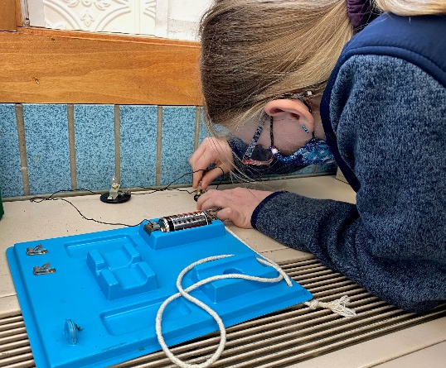
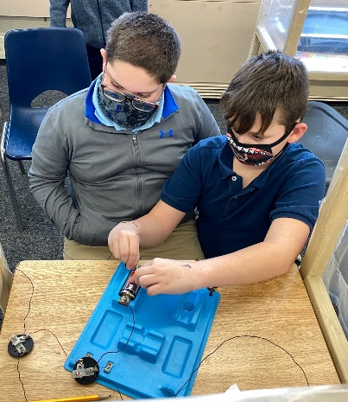

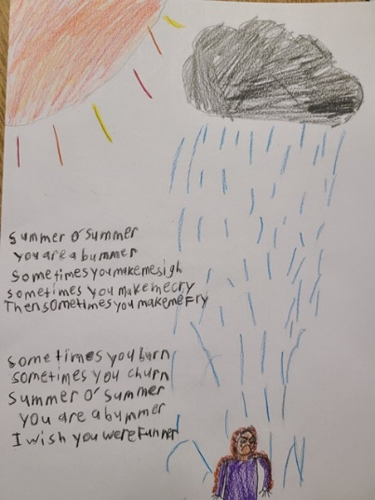
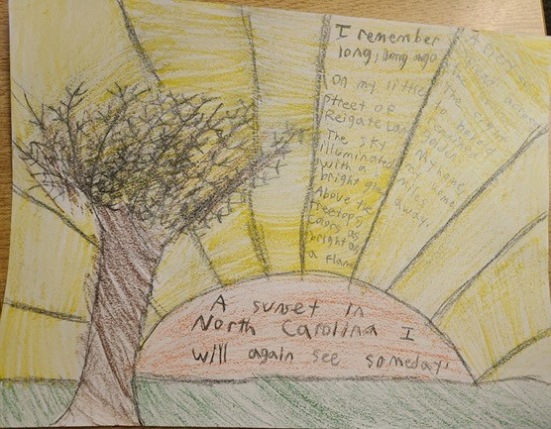
Fifth / Sixth Language Arts - In collaboration with Arts in Stark, fifth and sixth graders have been working on a poetry unit (Below)

Kindergarten Math - Math and art go together in Kindergarten class. The children painted piggy banks as a unit wrap up for learning about money and saving (Shown below)
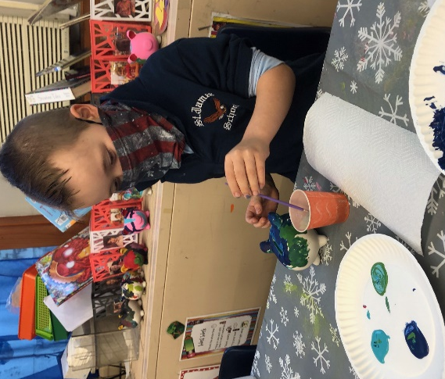
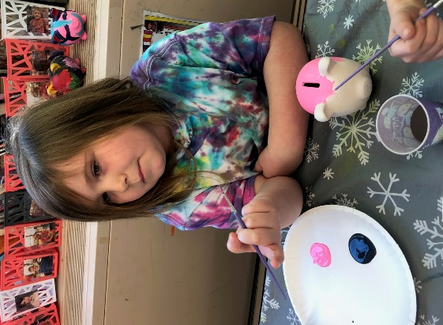
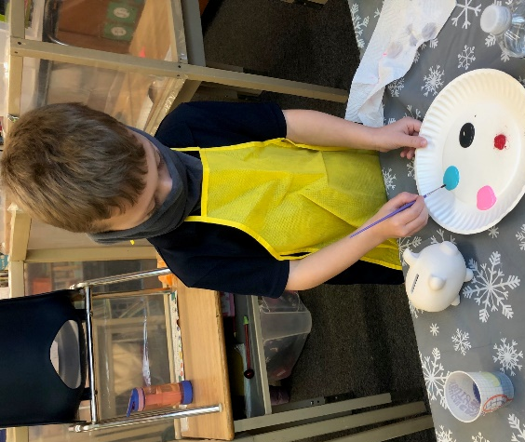
Testimonials from Parents
Kate Capurso – St. James School has been a blessing for our family. We are treated with respect and kindness. The school has provided the services my children need. I am happy we found St. James School for our children.
Mamie Gonzales – St. James is so much more than just a school. St. James is a caring community, a safe haven, a home away from home and an addition to your family. The staff at St. James embraces diversity, reflects the love of Catholic faith and inspires excellence in their students. The children come to St. James hungry to learn and leave full of the best education. God bless St. James for all they do for their students and families.
Dave and Christy Hunt – St. James is a wonderful school whose teachers and staff are amazing and are always prepared to go the extra mile for the students! St. James is a very family-oriented school who caters to each child’s individual needs and teaches about God and instills strong ethical values. We wholeheartedly recommend St. James School and feel privileged that they are a part of our family’s life.
Lindsay Morris – I love that St. James School has smaller classes and is able to be more one on one with my children. The staff is truly amazing! Such a blessing to all. I like that they do fundraisers to help kids and families that struggle financially. I love that my kids feel safe and at home. They are treated great and love attending St. James!
Student Testimonials
Alice Jones (Third Grade) – St. James is like when your cousins come to visit and you play and live together like a family, and learn too.
Bre Lonca (Third Grade)- I like being at St. James because it is really fun. Father Joe and everyone is so nice too.

Lacey Allen (Second Grade) -I like St. James because everyone is so nice to each other and I like getting to go to church!

Hunter Delong (Second Grade) - I like being here at St. James because I got to meet new people and make friends. I like going to church and I like that there are less students in my class then I had at my other school.

Daniel Friedman (Third Grade) - Being at St. James has been fun and I’ve made a lot of friends. I also love all the teachers and aides.

James Kelleher (Third Grade) - I like St. James because I get to work on a lot of Math and schoolwork. I also like the teachers because they are so nice. Riding the bus is super fun too.

